About Cornwall Air Ambulance Trust
Cornwall Air Ambulance Trust was the first service of its kind in the UK. Since our launch in 1987 we have flown over 25,000 missions and helped to save countless lives. We receive no central government or National Lottery funding to help with our running costs and so are reliant on the generosity of our supporters to keep the helicopter in the sky.
What is It’s A Cornish Knockout?
It’s A Knockout is a classic comedy game involving giant obstacles, water and lots of laughs! Teams battle it out against each other by playing silly games to see who will be crowned champions. The event promises to be full of fun and is a brilliant opportunity for any business, group of friends or community group looking to have a great day out.
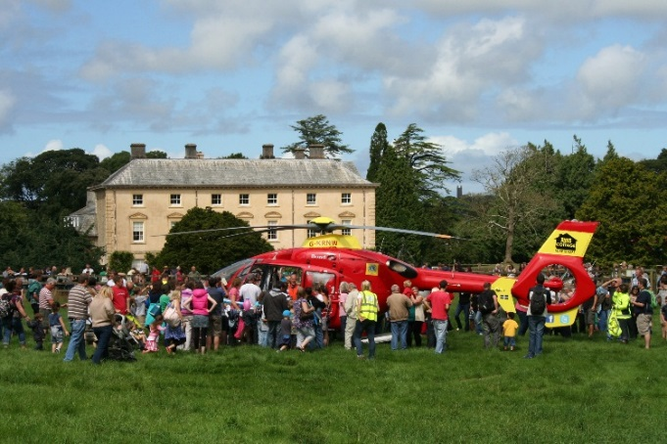
The It’s A Knockout event is being held alongside the annual Cornwall Air Ambulance Trust Family Fun Day so there’s lots to entertain the whole family as well as refreshments and a licensed bar – perfect for that celebratory drink after a fun-filled day!
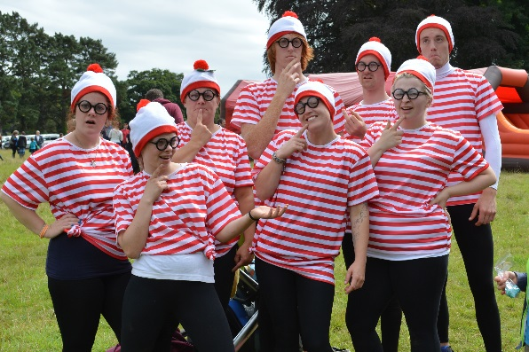

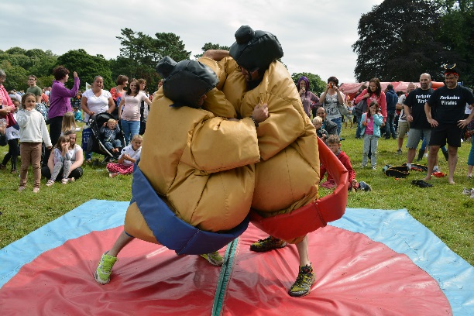

How do I get involved?
To take part, each team requires 6-10 people. Team entry costs £500 and many people may choose to raise the funds through sponsorship or other fundraising activities. If you’re not too keen on shaking a collection bucket, you can always just pay the entry fee yourself. However you decide to join in, fancy dress is encouraged! If you would like to enter a team please fill out the registration form overleaf and return to the address below. For more information, get in touch with the fundraising team on 01637 889926 or email becky@cornwallairambulancetrust.org.
Please complete the form for each team entered.
Contact name:…………………………………………………………………………………………………........................................................
Organisation (if applicable):……………………………………………………………………………………………………………………………
Address:…………………………………………………………………………………………………………………………………………………………
………………………………………………………………………………………………………………………………………………………………………Postcode:………………………………………………………………………………………………………………………………………………………..
Telephone:....................................................................................................................................................................................
Email:……………………………………………………………………………………………………………………………………………………………..
Team Name:……………………………………………………………………………………………………………………………………………………
No of Members:………………………………….................................................................................................................................
Contact name & mobile number on event day:……………………………………………………………………………………………....
We would like to enter a team and our preferred payment method is: fundraising / invoice
Please note, we require 50% of your fundraising to have reached us by Friday 3rd July 2015 to secure your place in the Knockout. The full sum is to be paid within two weeks after the event (7th September 2015).
Please outline any ways in which we can support you in your fundraising (we can supply you with collection jars and promotional material including balloons, ‘in aid of’ posters and sponsor forms)
………………………………………………………………………………………………………………….………………………………………………………………………………………………...............................................................................................................................................................................................................................................................................................................................................................
Are you happy for Cornwall Air Ambulance Trust to keep you updated on other events and send you our newsletter by email?
Yes / No
Sign: ………………………………………………….
Print: …………………………………………………
Date: …………………………………………………
PLEASE RETURN COMPLETED FORM TO:
Cornwall Air Ambulance Trust, Trevithick Downs, Newquay, Cornwall, TR8 4DY
or becky@cornwallairambulancetrust.org

